Gruodis
2021
Vladimiras Zubovas  Lithuanian architect, architectural historian. During the war, he and his wife rescued Jews from the Kaunas ghetto, took care of them and provided documents. 1991 awarded the title of Righteous Among the Nations, 1999 awarded the Cross of Salvation. | 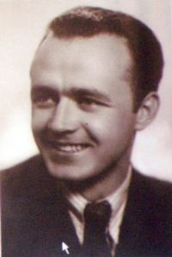
Pirmadienis | Antradienis | Trečiadienis | Ketvirtadienis | penktadienis | šeštadienis | Sekmadienis
 |  | 1 | 2 | 3 | 4 | 5
6 | 7 | 8 | 9 | 10 | 11 | 12

Vladimiras Zubovas 1909

13 | 14 | 15 | 16 | 17 | 18 | 19
20 | 21 | 22 | 23 | 24 | 25 | 26
27 | 28 | 29 | 30 | 31

