Lapkritis
2021
Kazys Binkis  Lithuanian poet, writer, journalist, playwright. During World War II, he hid Jews in his apartment with his wife, Sofia. After their death, they were given the names of the righteous of the nations of the world. A tree in honor of Sofia and Kazys Binkis was planted at the Yad Vashem Museum in Israel, Righteous Alley . | 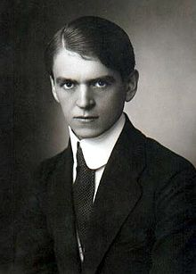
Pirmadienis | Antradienis | Trečiadienis | Ketvirtadienis | penktadienis | šeštadienis | Sekmadienis
1 | 2 | 3 | 4 | 5 | 6 | 7
8 | 9 | 10 | 11 | 12 | 13 | 14
15 | 16 | 17 | 18 | 19 | 20 | 21
 | Kazys Binkis 1893
22 | 23 | 24 | 25 | 26 | 27 | 28
29 | 30

