Liepa
2021
Pasaulio teisuoliai  July 4 and 6 d. By order of Karl Jäger, the head of the 3 / A operative squad, the National Labor Protection Battalion formed of Lithuanian rebels shot almost 3,000 Kaunas Jews. By his order, Joachim Hamann a flying squad with the help of the Lithuanian Security Police from July 7. until October 2. killed the Jewish communities of almost all Lithuanian towns - children, women, the elderly. But there were People who resisted this cruelty, who rescued, hid, took care of ... | 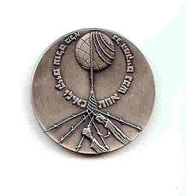
Pirmadienis | Antradienis | Trečiadienis | Ketvirtadienis | penktadienis | šeštadienis | Sekmadienis
 |  |  | 1 | 2 | 3 | 4
Povilas Karpavičius
1909m.
5 | 6 | 7 | 8 | 9 | 10 | 11
Stanislava Jakševičiūtė
1874m
12 | 13 | 14 | 15 | 16 | 17 | 18
 |  | Ona Jablonskytė-Landsbergienė  1894m. | Henrikas Jonaitis 1913m.
19 | 20 | 21 | 22 | 23 | 24 | 25
26 | 27 | 28 | 29 | 30 | 31
Elena Kutorgienė
1888m.
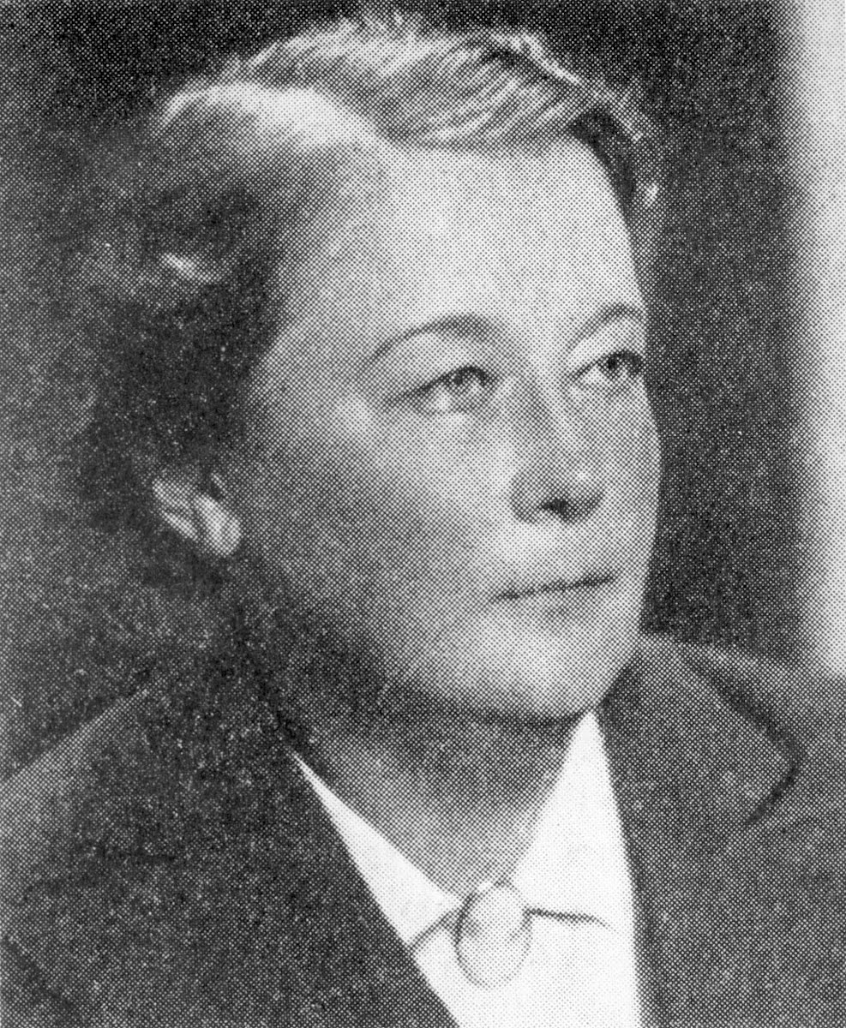
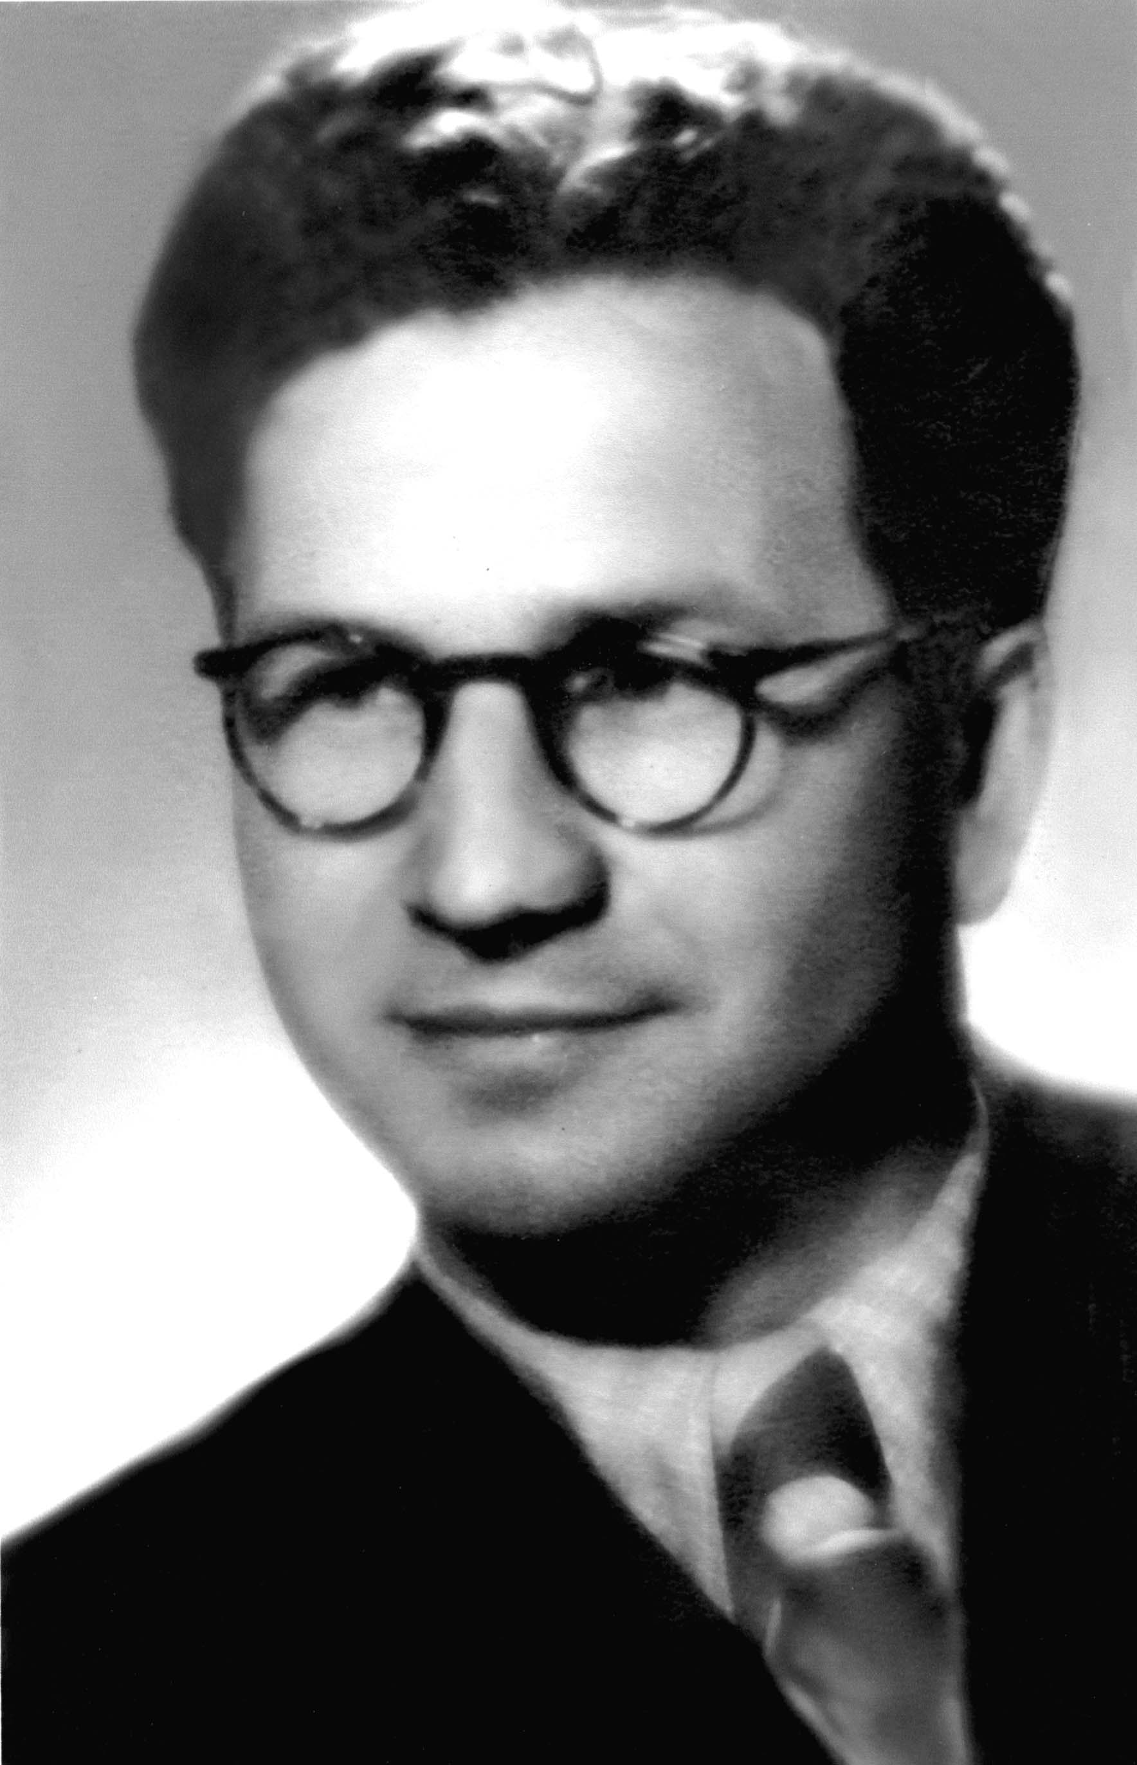
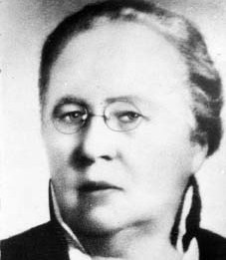
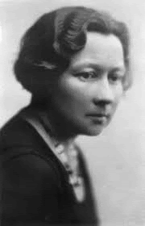
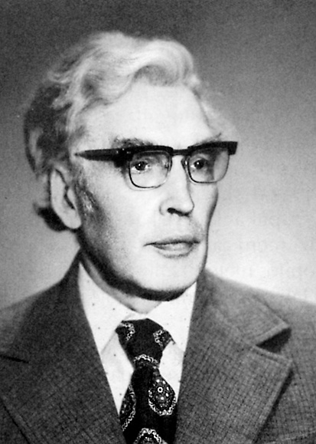
Povilas Karpavičius
Stanislava Jakševičiūtė

Ona Jablonskytė-Landsbergienė
Henrikas Jonaitis
Elena Kutorgienė
Henrikas Jonaitis
Elena Kutorgienė

